-Berke Can KAYA

-Görkem Enes BEKTAŞ

**Signal Analysis and Data Processing Laboratory – REPORT**

**Experiment - 2**

**Compulsory Tasks**

1. **perform statinarity test for either random or compound signal**

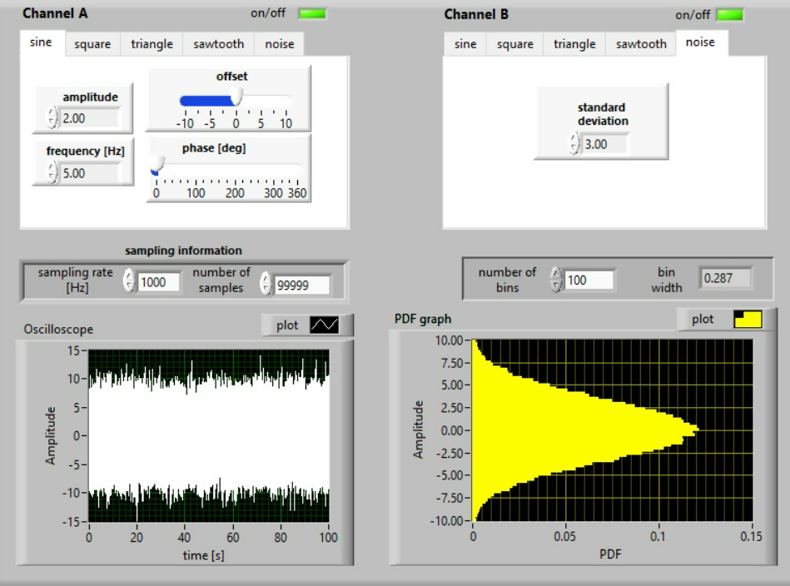

**Figure 1.1 Number of samples=99999=max, smooth graph**

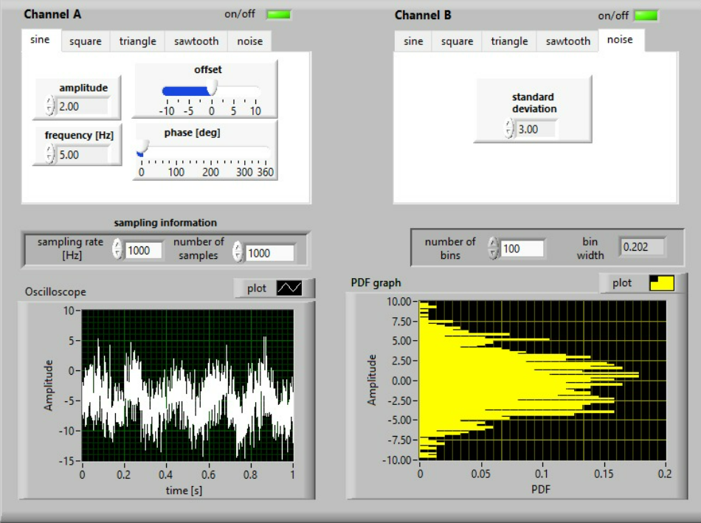**Figure 1.2 Number of samples=1000, unclear graph**

1. **estimate the required number of intervals (bins) ensuring smooth PDF distribution for the selected signal**

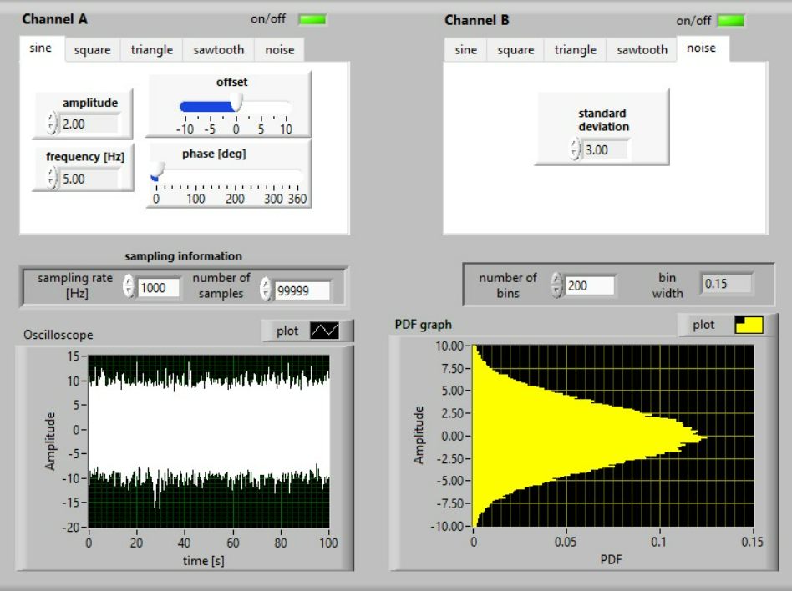

**Figure 2.1 Number of bins=200, smooth graph**

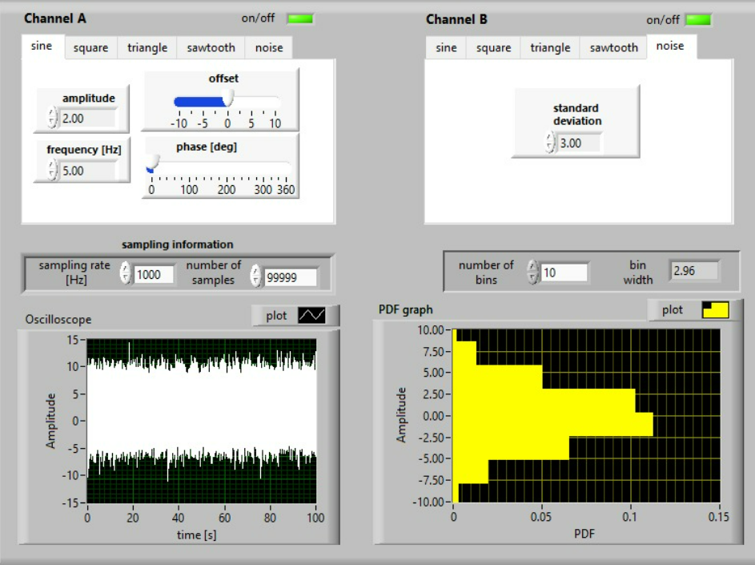

**Figure 2.2 Number of bins=10, unclear graph**

1. **determine the PDF distributions for typical deterministic signals**

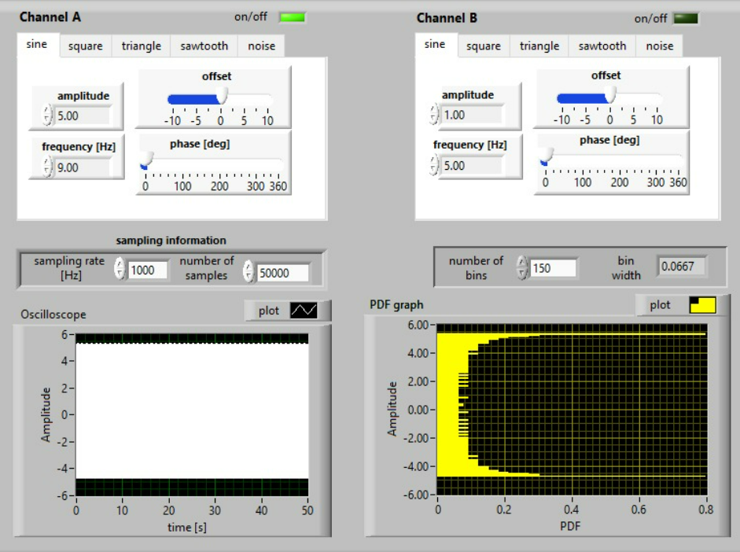

**Figure 3.1 Sampling Rate=1000Hz, unclear graph**

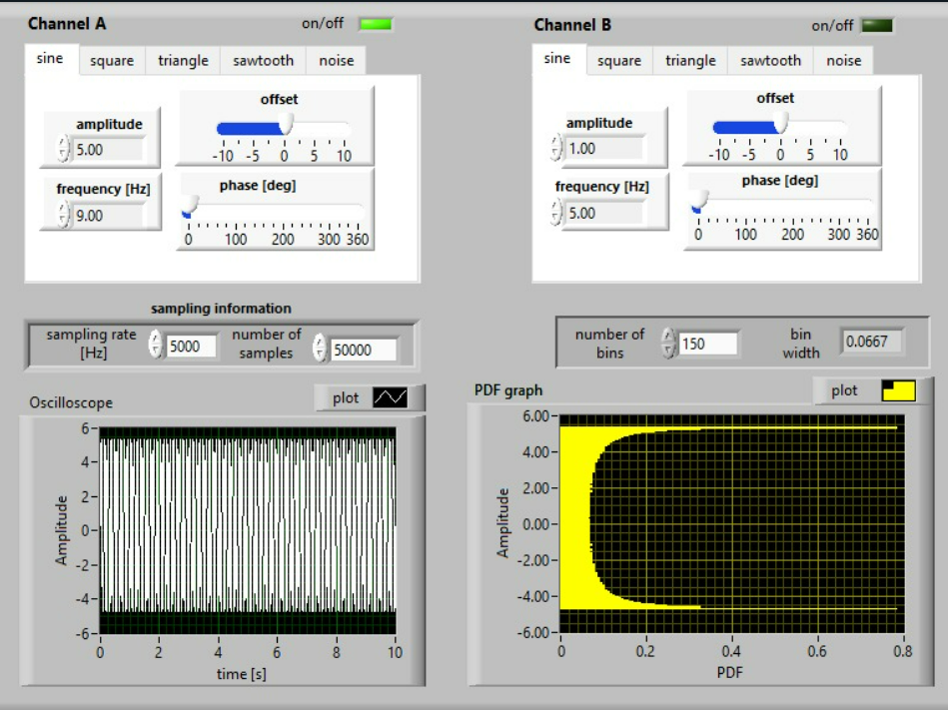

**Figure 3.2 Sampling Rate=5000Hz, smooth graph**

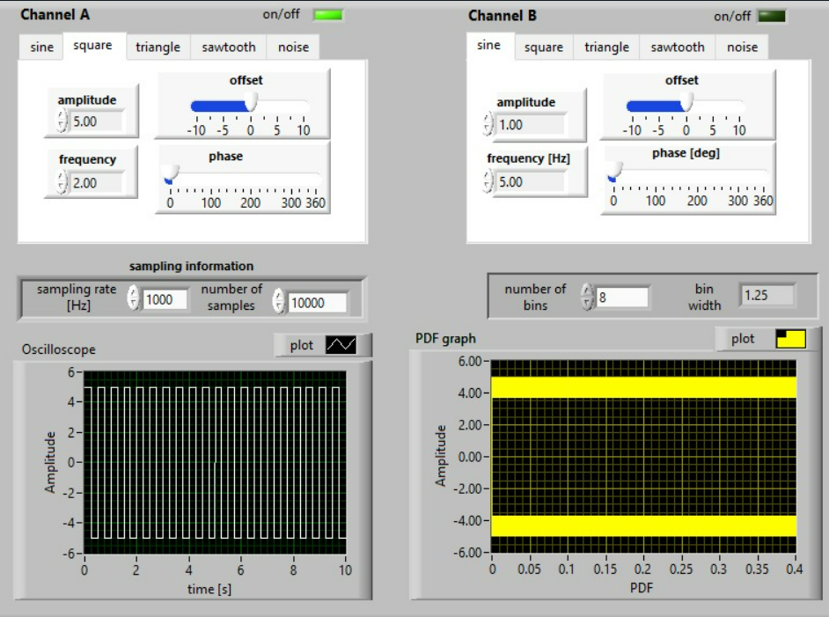

**Figure 3.3 Square Wave**

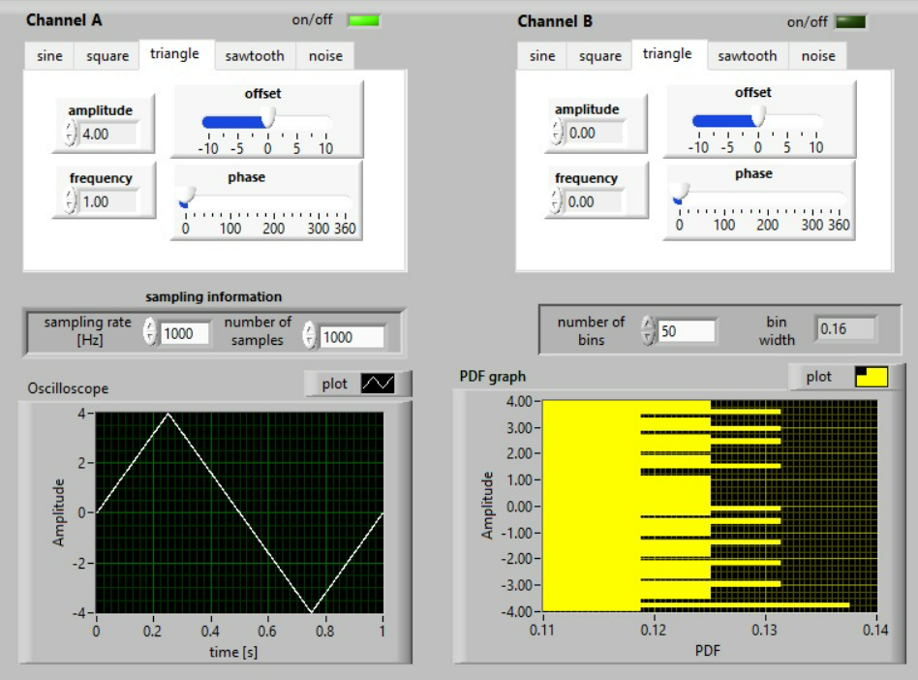

**Figure 3.4 Triangle Wave**

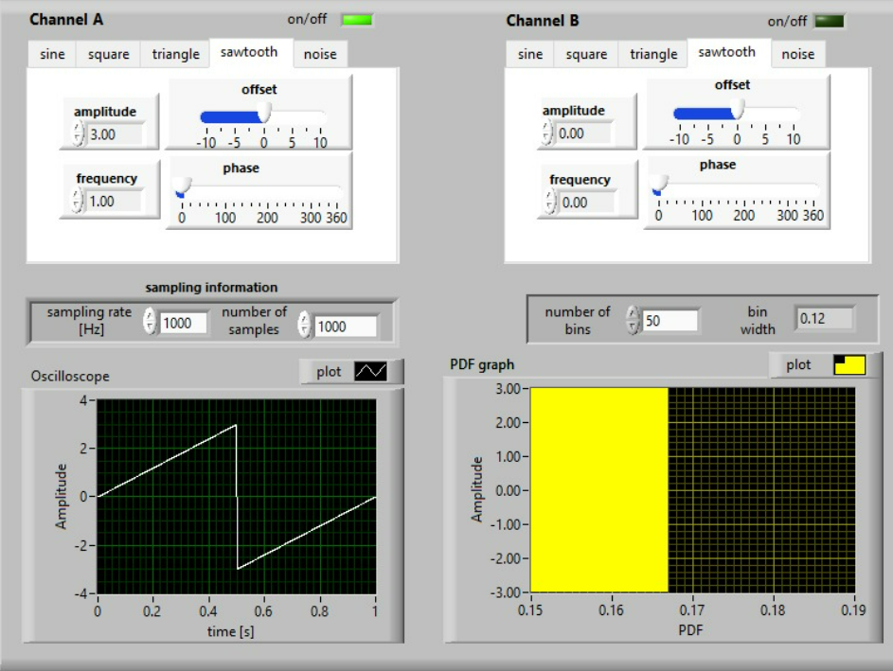

**Figure 3.5 Sawtooth Wave**

**d) determine the PDF distributions for selected compound signal changing the level of noise contribution**

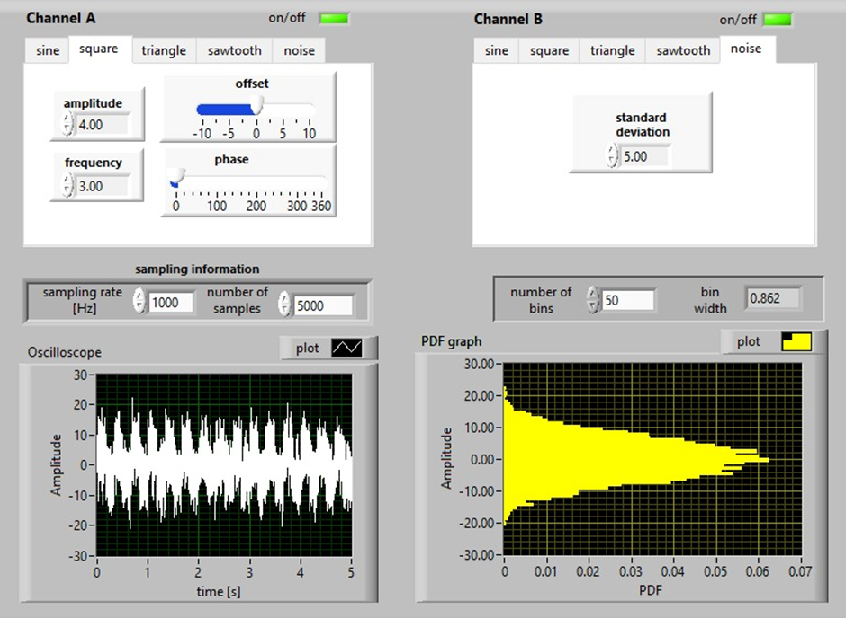

**Figure 4 square + noise; amplitude =4, standard deviation = 5**

N = σ2sig = σ2squ + σ2noise  σ2squ = Amplitude

N = 42 + 52 = 16+25 =41

%Total Power = $\frac{Power of noise}{Power of signal}×100= \frac{25}{41}×100=\%60,97$

If the amplitude goes up or the standard deviation goes down, the graph becomes more visible, easier to recognize.